National Institute of Technology Silchar
Mid-Semester (UG) Examination, Sept’2017
Subject code: EC1402 Subject: Power Electronics
Semester: 7th Branch: ECE
Duration: One Hour Total Marks: 30
Figure in the right margin indicated full marks for the question
Q.1 | a) Differentiate between inverter grade and converter grade SCR ?  b) In SCR, why the doping of n₁ layer is lesser than other layers ?  c) Why circuit turn off time is more than device turn off time ?  d)In power MOSFET, what is the function of parasitic BJT ? | 2X4
Q2. | Draw the exact equivalent circuit of IGBT from its structural details. Enumerate the differences considering the SOA of Power MOSFET and IGBT. | 5
Q3. | a) The gate cathode characteristic of an SCR is given by For a triggering frequency of 400 Hz and duty cycle of 0.1, compute the value of resistance to be connected in series with the gate circuit. The rectangular trigger pulse applied to the gate circuit has an amplitude of 12 V. The thyristor has average gate power loss of 0.5 watts. | 5
Q4. | a)The turn off process in a GTO can be described with its two transistor model. Explain in detail.  OR  b) Discuss the basic working principle of TRIAC considering its constructional diagram. | 4  4
Q5. | A DC battery of constant emf E is being charged through a resistor as shown in Fig. 1. For source voltage of 230 V, 50Hz and for R=8Ω, E=150V a) find the value of average charging current (b) find the power supplied to battery and that dissipated in the resistor. (c) supply power factor .  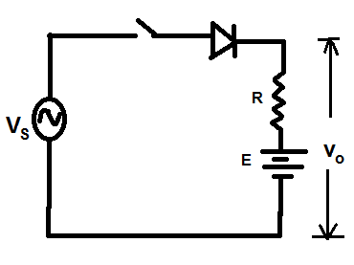Fig.1 | 4
Q6. | Determine the average output voltage for Single phase semiconverter bridge as shown in Fig.2 . Also draw V_{o}, i_{o}, i_{fd}, V_{T1.}  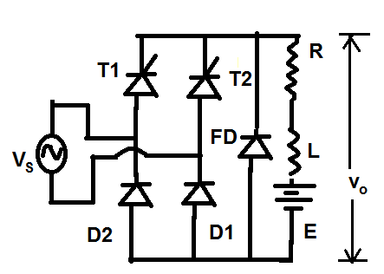  Fig.2 | 4

